

InstallShield®

AdminStudio

Setup

Specification

Owner(s) Jigar Desai

Last Updated 8/24/2004 11:17:00 PM

File Name 0000.doc

© 1999 InstallShield Software Corporation. All rights reserved.
THIS IS PRELIMINARY DOCUMENTATION. The information contained in this document represents the current view of InstallShield Software Corporation on the issues discussed as of the date of publication. Because InstallShield must respond to changing market conditions, it should not be interpreted to be a commitment on the part of InstallShield, and InstallShield cannot guarantee the accuracy of any information presented after the date of publication.
This BETA document is for informational purposes only. INSTALLSHIELD MAKES NO WARRANTIES, EXPRESS OR IMPLIED, IN THIS DOCUMENT.
Other product or company names mentioned herein may be the trademarks of their respective owners.
InstallShield Software Corporation • 900 National Parkway • Schaumburg, Illinois 60173-5108

Table of Contents

1.0 Abstract 3
2.0 Perseus Setup 3
3.0 AdminStudio OEM 8
4.0 Requirements 9
5.0 Perseus Upgrade 9
6.0 Command Line 10
7.0 Issues 10
8.0 Revision History 10

1.0 Abstract
The purpose of this document is to discuss the issues related to the InstallShield AdminStudio Perseus setup.

2.0 Perseus Setup

The Perseus setup project is located in MSI_VSS here: $/InstallShield AdminStudio/Current/Build/Support/AdminStudio.ism. Final build will be on: \\testengineering\builds\AdminStudio\6.0 (Perseus)

I UI – Following dialogs will be available in UI sequence.

1. Welcome:
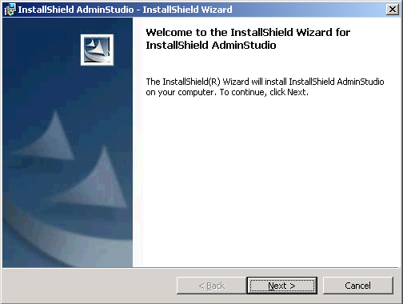

2. License Agreement:
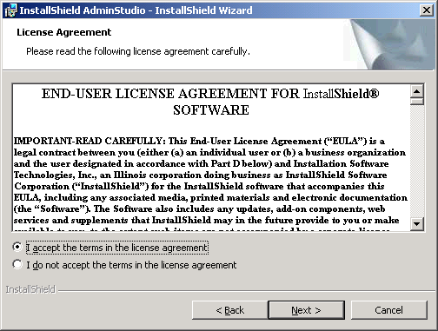

3. Customer Information:
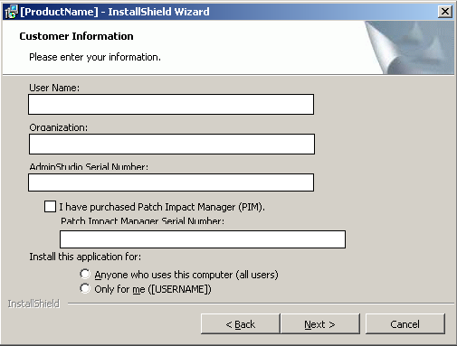

4. Destination Folder:
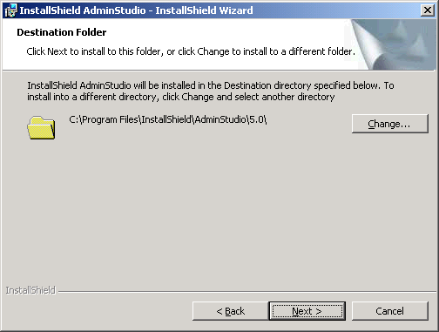

AdminStudio Shared Location:
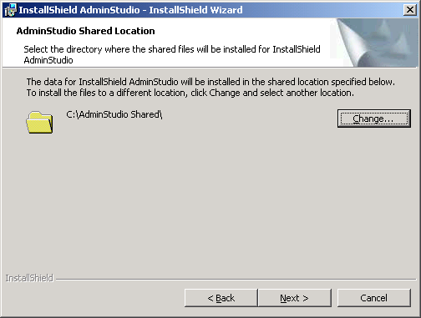

Select Language:
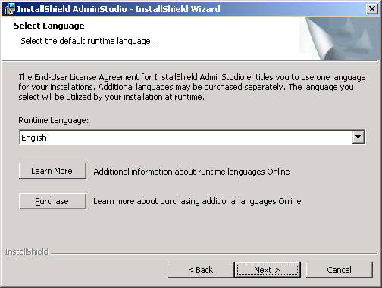

Custom Setup:

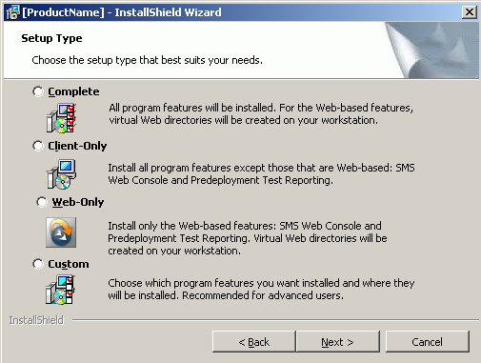

If IIS is not installed on the machine then
Complete and Web-Only options will be disabled.

- Complete Option will install all the files and create web sites for PreDeployment and SMS Distribution.
- Client-Only will install all the client related files including PreDeployment client files. This option will not install PreDeployment web related files and SMS Distribution files. Also, it will not create web sites for PreDeployment and SMS Distribution.
- Web-only will install only web related files and web sites for PreDeployment and SMS features
- Custom will display features selecttion dialog with PreDeployment and SMS features not selected if IIS is not installed

Ready to Install the Program:
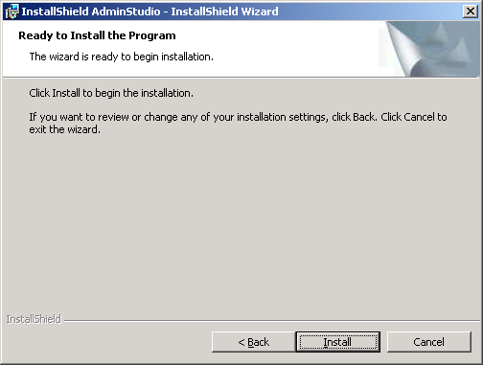

II Tools included in the AdminStudio
ConflictSolver
Application Isolation Wizard
Repackager
Legacy Converter
OSSnapshot
Global Exclusion Editor
Remote Repackager (Setup file to install on clean machine)
Tuner (using Tuner Stand alone Merge Module)
Distribution Wizard
InstallShield X (using merge modules, see InstallShield X integration section)
QualityMonitor
Patch Impact Manager
PreDeployTest

III InstallShield X Integration
AdminStudio Perseus uses four InstallShield X Merge Modules:
DevStudioCoreMoule.msm – Contains the core files and functionality
DevStudioVSIPModule.msm – contains the VSIP integration components
DeStudioISRedistsModule.msm – contains the InstallShield merge modules
DevStudioThirdpartyRedistModules.msm – contains MS merge modules
DevStudioStandalonebuildCoreModule.msm – DevStudio standalone build
VC_STL.msm
VC_CRT.msm

DevStudioCoreMoule.msm, DeStudioISRedistsModule.msm, DevStudioThirdpartyRedistModules.msm, VC_STL.msm, VC_CRT.msm and DevStudioStandalonebuildCoreModule.msm will be installed by default with Perseus release. If .NET is installed on the machine then this feature will be displayed in the Custom setup dialog. If .NET is not installed then this feature will not be displayed in Custom Setup dialog. If user installs any .NET framework after installing AdminStudio Perseus then users can go to the Add/Remove Programs and use modify options of AdminStudio to install VSIP.

AdminStudio installs following files for InstallShield X integration:
Developer.ini installed to AdminStudio Common folder
Developer Views files (from $/InstallShield AdminStudio/Current/program/Dev0409) installed to AdminStudio Program 0409 folder

AdminStudio creates following Registry entries for InstallShield X integration:
[HKEY_LOCAL_MACHINE\Software\InstallShield\10.0\Professional]
"developer.ini"="[INSTALLDIR]Common\Developer.ini"
"default.nav.1"="[INSTALLDIR]DevStudio\Program\0409\isproadmin.nav"

[HKEY_LOCAL_MACHINE\SOFTWARE\InstallShield\AdminStudio]
"CurrentVersion"="[REGVER]" where REGVER 6.0
"ASLocation"="[INSTALLDIR]"

IV Shortcuts
Start | Program menu | AdminStudio 6
Start | Program menu | Patch Manager (if PIM serial number entered)
Start | Program menu | AdminStudio| AdminStudio 6 Tools | {Tools Shortcuts}

V Product Information
Product Name: InstallShield AdminStudio
INSTALLDIR: [Program Files]InstallShield\AdminStudio\6.0
Product Code: {A0025214-795F-4BB1-9406-7A4197749D46}
Version: 6.0
Editions: Setup installs all the files on the machine. AdminStudio will turn on/off features based on serial number entered by users
Professional Edition:
ConflictSolver
Application Isolation Wizard
Repackager
Tuner
Distribution Wizard
InstallShield X
QualityMonitor
Standard Edition:
Application Isolation Wizard
Repackager
Tuner
Distribution Wizard
InstallShield X
Enterprise Edition:

Serial Numbers:
Professional: APFBDA-0600-7040000005 Increament by 13
Standard: ASFBDA-0600-7040000007 Increament by 19
Enterprise: AEFBDA-0600-A040000003 Increament by 11

Patch Impact Manager Serial Number:
AHAADA-0100-5040000005 Increament by 13

ZENworks Edition Serial Numbers:
ANFBDA-0600-8040000007 Increament by 11

SMS Edition Serial Numbers:
AMFBDA-0600-7040000003 Increament by 17

VI Update Service Version
AdminStudio Perseus setup will use following updated service versions to differentiate between editions.

Eval of Professional + PIM Eval
ZENworks ZENworks
SMS SMS
Full (direct or from Eval) Full
Full + PIM (direct or from Eval) FullPIM
Full (from ZENworks) FullZEN
Full + PIM (from ZENworks) FullPIMZEN
Full (from SMS) FullSMS
Full + PIM (from SMS) FullPIMSMS

3.0 AdminStudio OEM

AdminStudio full RTM image with minor change will be shipped to OEM customers and as eval.
OEM edition and eval edition will not have any serial numbers. OEM Customers will activate the AdminStudio on first use.
Setup UI will reflect product name based on EDITION property at installation time. A Custom Action SetProductName will set the product Name based on OEMPRODUCTNAME property.

So OEM edition following two properties will be set:
Set EDITION property to SMS for SMS edition and NOVELL for ZENworks edition
Set OEMPRODUCTNAME property to AdminStudio SMS Edition for SMS edition and AdminStudio ZENworks Edition for ZENworks edition.

1. ZENworks Edition:
Product Name: AdminStudio for ZENworks
UI Sequence: (Setup will not display Setup Type and Language selection dialog)
Install:
- Welcome dialog
- License Agreement dialog
- Customer Information dialog
- Destination Folder dialog
- AdminStudio Shared Location dialog
- Ready to Install dialog
Maintenance:
- Maintenance Welcome dialog
- Maintenance Type dialog
  - ReadyToInstall dialog (if choose Repair/Remove option)
Custom Setup (if choose Modify option)
2. SMS Edition:
Product Name: AdminStudio for SMS
UI Sequence: (Setup will not display Setup Type and Language selection dialog)
- Welcome dialog
- License Agreement dialog
- Customer Information dialog
- Destination Folder dialog
- AdminStudio Shared Location dialog
- Setup Type dialog (Custom option will not be available)
- Ready to Install dialog
Maintenance:
- Maintenance Welcome dialog
- Maintenance Type dialog
  - ReadyToInstall dialog (if choose Repair/Remove option)
Custom Setup (if choose Modify option)

If IIS is installed on the machine then all files except PreDeploement web files will be installed and SMS Distribution web site will be created.
If IIS is not installed on the machine then Ready To Install dialog will display text that web sites will not be created. Setup Install Client and web related files except Predeplyment web.

4.0 Patch Impact Manager
Patch Impact Manager is add-on product for AdminStudio and it is not available if AdminStudio ZENworks edition and AdminStudio SMS edition is installed on the machine.
Users can add serial number on Customer information dialog. If “I have purchased Patch Impact Manager” option is checked then Patch Impact serial number edit box will be displayed and serial number can be entered.
Patch Manager.exe doesn’t get installed if Patch Impact Manager serial number is not entered and validated.
If users decided to purchase after installing AdminStudio then Patch Impact Manager can be activated in Maintenance mode where they will have option to choose activate Patch Impact Manager as shown in dialog below:

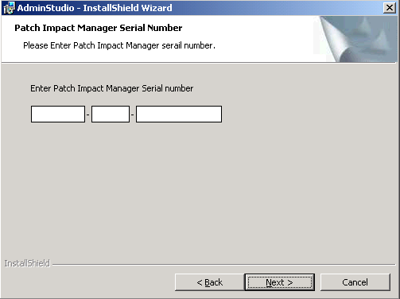

5.0 Evaluation Edition
AdminStudio full RTM image with minor change will be shipped to as eval.
Eval edition will not have any serial numbers. Setup UI will reflect product name based on EDITION property at installation time. A Custom Action SetProductName will set the product Name based on OEMPRODUCTNAME property.
Patch Impact Manager is included in Eval edition.

Product Name: AdminStudio Evaluation
UI Sequence: (Setup will not display Setup Type and Language selection dialogs)
Install:
- Welcome dialog
- License Agreement dialog
- Customer Information dialog
- Destination Folder dialog
- AdminStudio Shared Location dialog
- Setup Type dialog with all the options (Client/Complete/Web/Custom)
- Ready to Install dialog
Maintenance:
- Maintenance Welcome dialog
- Maintenance Type dialog
  - ReadyToInstall dialog (if choose Repair/Remove option)
Custom Setup (if choose Modify option)

6.0 Requirements
Target machine requirements are
User must logged in with Power User rights
OS must be NT 4 with SP6 or higher/2000/xp
IE 5.0 or higher

If any of these requirements are not met, the setup should abort with an appropriate error message.

IIS required if SMS and PreDeployment features needs to be installed

7.0 Perseus Upgrade

This section describes the Upgrade scenarios for AdminStudio Perseus.
Scenario 1: Install AS 2.0. Install Perseus.
Expected Result: Major Upgrade

Scenario 2: Install AS 3.0. Then install AdminStudio Perseus.
Expected Result: Major Upgrade

Scenario 3: Install AS 3.01. Then install AdminStudio Perseus.
Expected Result: Major Upgrade

Scenario 4: Install AdminStudio 3.5 (include Developer 7.04). Install AdminStudio Perseus.
Expected Result: Ask users to manually uninstall AdminStudio 3.5

Scenario 5: Install AdminStudio 3.5 Value Pack 1/Value Pack2. Install AdminStudio Perseus.
Expected Result: Major Upgrade

Scenario 6: Install AdminStudio 5.0. Install AdminStudio Perseus.
Expected Result: Major Upgrade

Scenario 7: Install AdminStudio 5.0. Install SP1. Install AdminStudio Perseus.
Expected Result: Major Upgrade

Scenario 8: Install AdminStudio 5.0. Install VP1. Install AdminStudio Perseus.
Expected Result: Ask users to uninstall AdminStudio 5 VP1 manually

Scenario 9: Install Developer 8. Install Perseus.
Expected Result: AdminStudio Perseus and Developer 8 can co-exist.

Scenario 10: Install DevStudio 9.0. Install AdminStudio Perseus.
Expected Result: AdminStudio Perseus and DeStudio 9 can co-exist.

Scenario 11: Install any full version of AdminStudio 5.5. Install AdminStudio Perseus.
Expected Result: Major upgrade

Scenario 12: Install any version of AdminStudio full Edition. Install AdminStudio Perseus eval edition.
Expected Result: prompt users to uninstall full edition before installing eval edition

Scenario 13:
Install any version of AdminStudio. Install OEM edition
Expected Result: prompt users to uninstall full edition before installing OEM editions.

6.0 Command Line

Perseus supports all the command line installation options such as
Silent install (/qn, /qb, /qr and /qf),
Advertisement (/ju, /jm) and
Administrative install (/a).

7.0 Issues

8.0 Revision History

Date | Author | Change Reference
06/02/2004 | Jigar Desai | Initial Draft
08/02/2004 | Jigar Desai | Revised

